Architecture Diagram
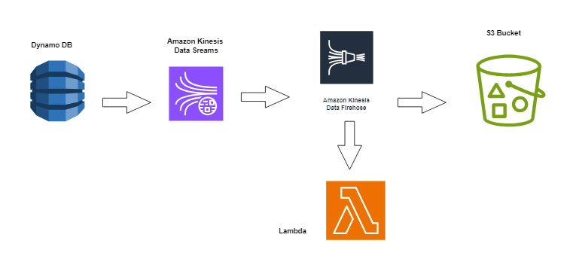
[Data Source]
|
v
+-----------------+
| Kinesis Firehose|
+-----------------+
|
v
+-----------------+
| AWS Lambda |
+-----------------+
| \
v v
+-----------------+ +----------------+
| DynamoDB | | S3 |
+-----------------+ +----------------+
|
v
+-----------------+
| SNS |
+-----------------+
|
v
+-----------------+
| CloudWatch Events|
+-----------------+

